SIMATS ENGINEERING
ASSESSMENT TOOL 3

COURSE NAME: Database Management Systems COURSE CODE: CSA05

I Pragadish (192572030) certify that this submission is my original work and that I have adhered to the guidelines specified for this assessment. I understand that any violation of academic integrity rules will result in disciplinary action.

Signature of the student:
Pragdish.R

ANSWER:

- Identify and correct errors in a given SQL CREATE TABLE statement with incorrect syntax and missing constraints.

Incorrect Query:

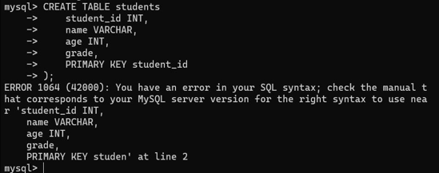

Corrected Query:

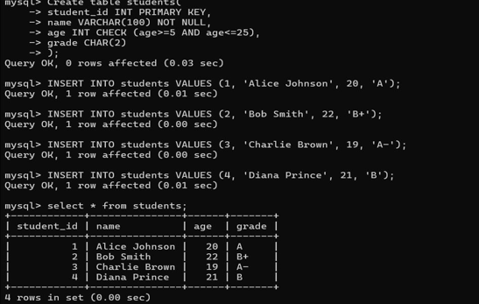

Errors Fixed:
- Missing parentheses around column definitions
- VARCHAR missing size parameter
- 'grade' column missing data type
- PRIMARY KEY syntax incorrect (should be after column definition or with parentheses)

Debug an SQL query that incorrectly uses aggregate functions without GROUP BY and fix the issue.
Incorrect Query:
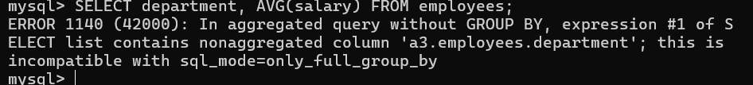

Corrected Query:
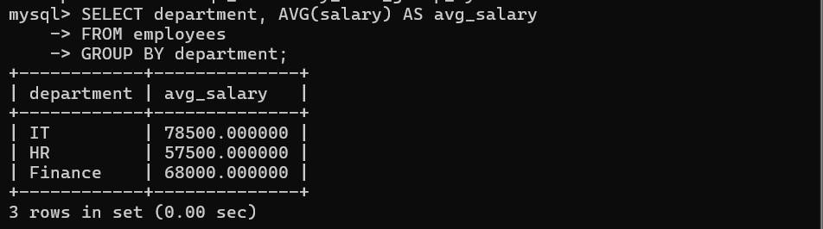

Error Fixed: Added GROUP BY department to aggregate salaries by department

Correct a faulty SELECT query where column names are misspelled or improperly referenced.

Incorrect Query:

Corrected Query:

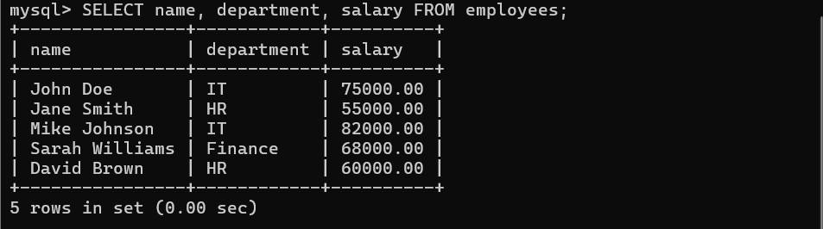
Error Fixed: Corrected column names: emp_name→name, depatment→department, sallary→salary

Fix errors in an SQL query using JOIN, where the join condition is missing or incorrect.

Incorrect Query :
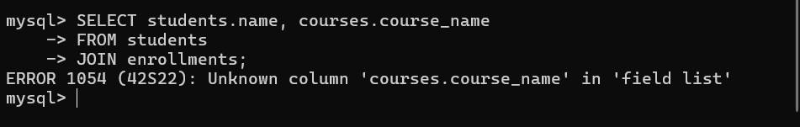

Corrected Query:
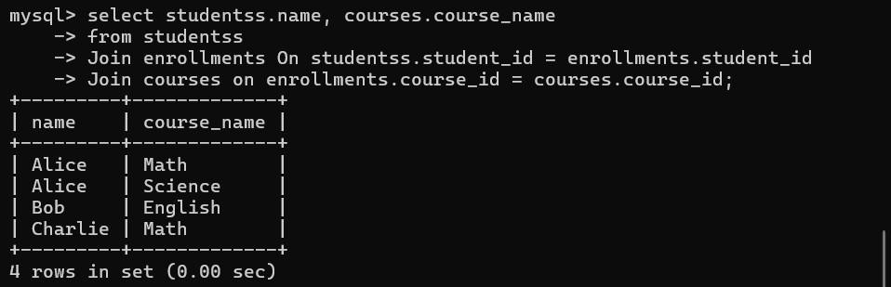
Error Fixed: Added proper JOIN conditions

Identify and correct a subquery error where multiple values are returned instead of a single value:

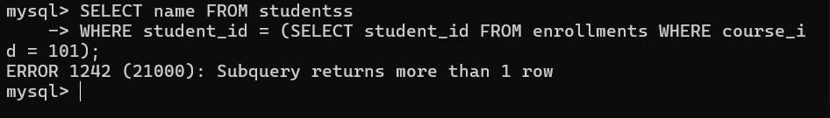
Incorrect Query:

Corrected Query:
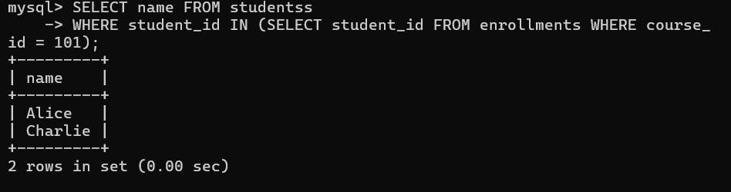

Error Fixed: Changed '=' to 'IN' when subquery returns multiple values.

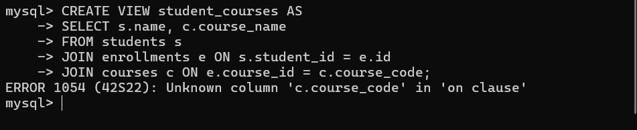
Debug a VIEW creation statement that contains invalid column references or syntax errors.

Incorrect Query:

Corrected Query:
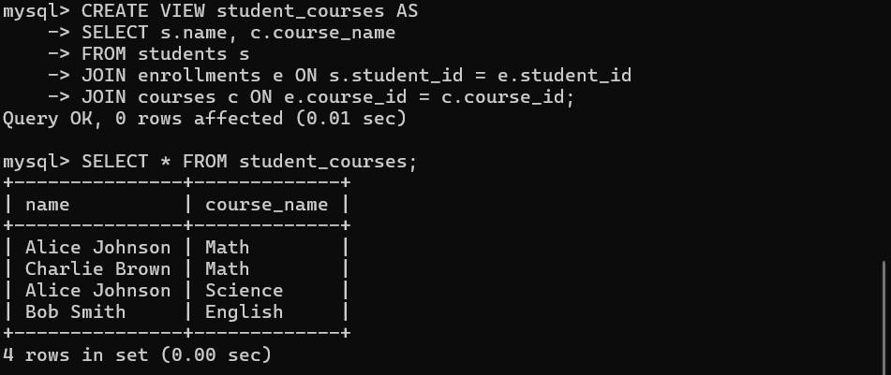

Errors Fixed:
- Corrected c.course_code to c.course_id
- Corrected e.id to e.student_id

Examine an SQL query with unnecessary conditions and optimize it by simplifying the WHERE clause.
Incorrect Query:
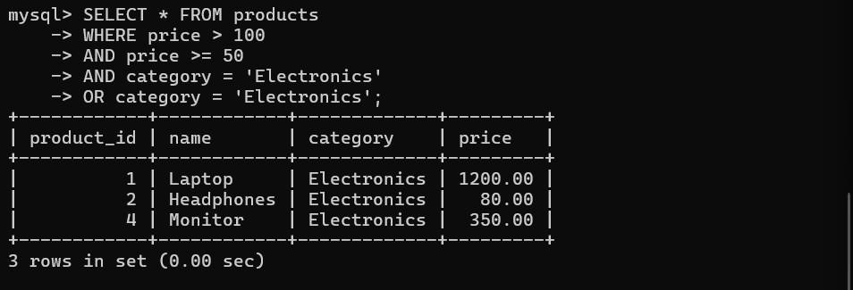

Corrected Query:
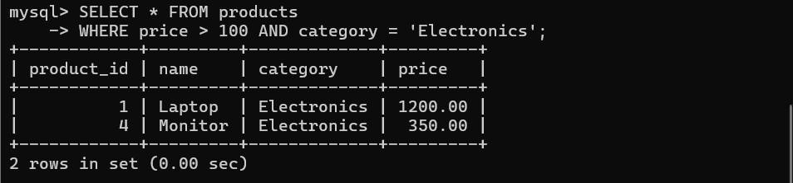

Error Fixed : Removed redundant conditions (price >= 50 was redundant with price > 100, and duplicate category condition)

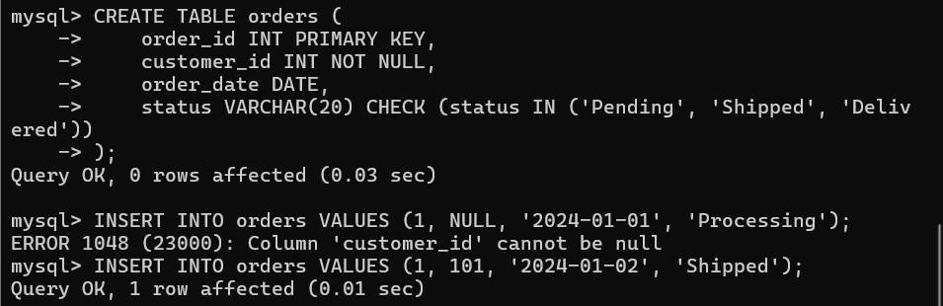
Identify violations of integrity constraints in a given table and correct them. Incorrect Query:

Corrected Query:

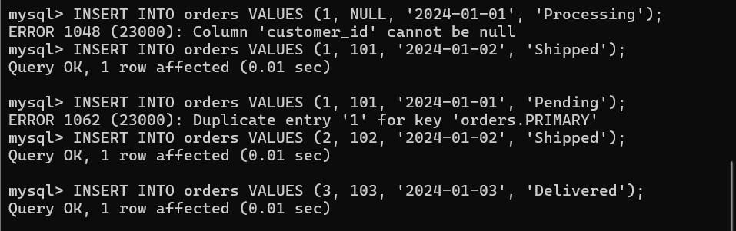

Errors Fixed:
  - customer_id cannot be NULL (NOT NULL constraint)
  - status must be one of: 'Pending', 'Shipped', 'Delivered' (CHECK constraint)
  - order_id must be unique (PRIMARY KEY constraint)

Fix a relation that violates 1NF or 2NF by removing repeating groups or partial dependencies. Incorrect Query:
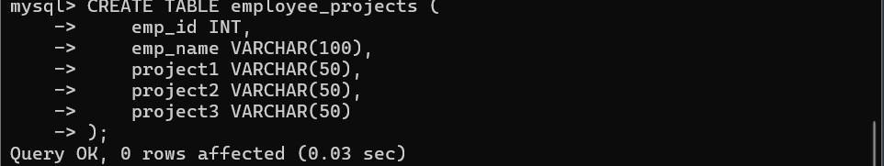

Corrected Query:
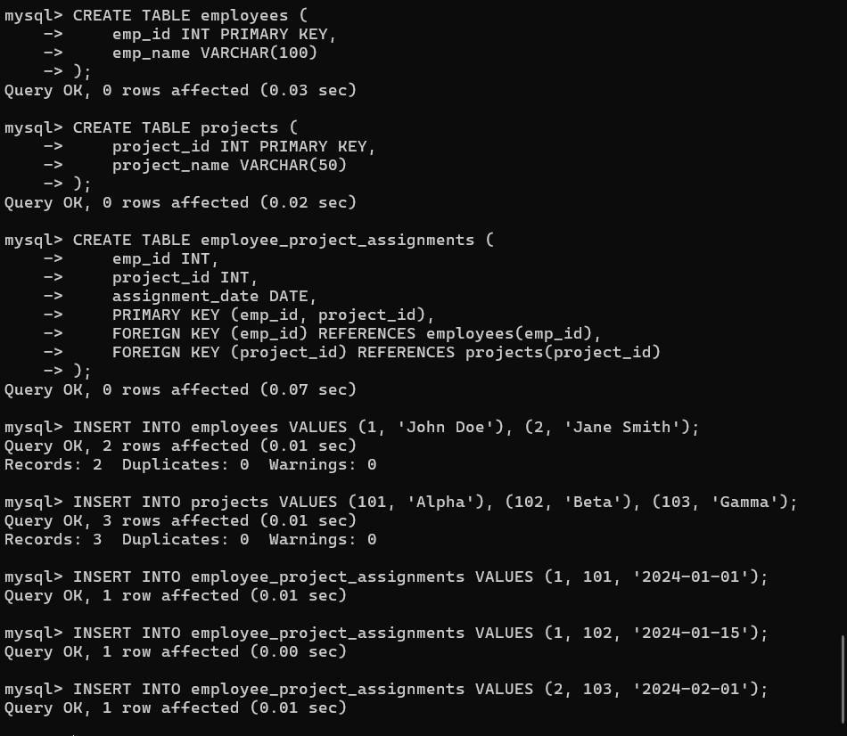

Identify redundant attributes in a relation and apply basic normalization (up to 3NF) to improve design.
Incorrect Query:
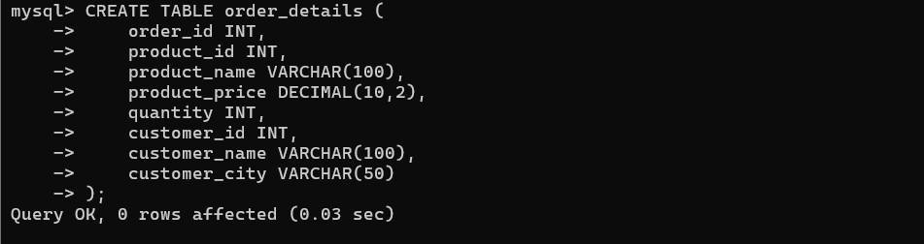

Corrected Query:

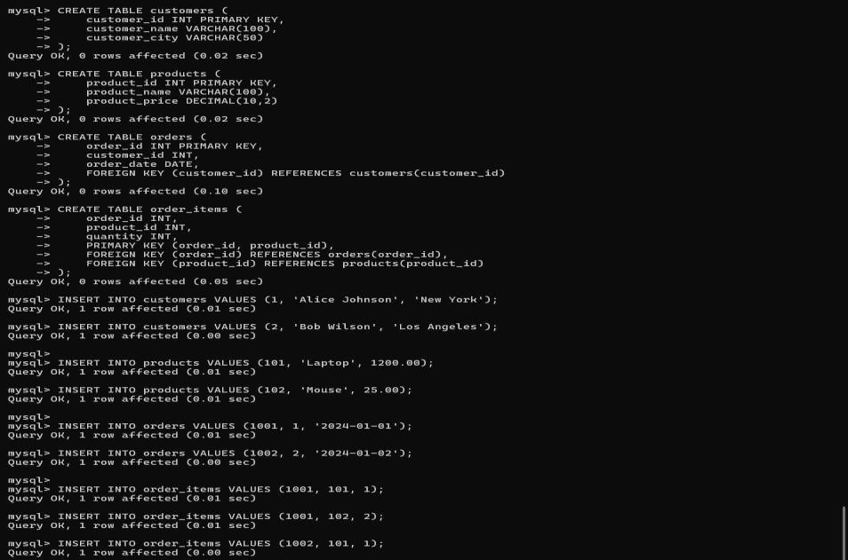

Error Fixed:
- Eliminated redundant customer and product data
- Separated into logical tables (Customers, Products, Orders, OrderItems)
- Achieved 3NF by removing transitive dependencies
- product_price depends on product_id, not order_i

